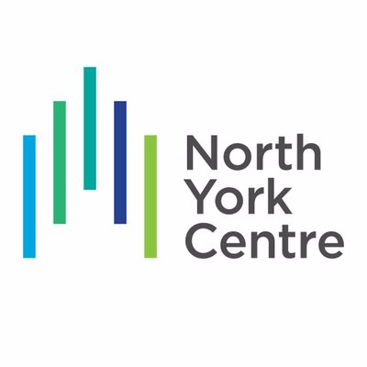
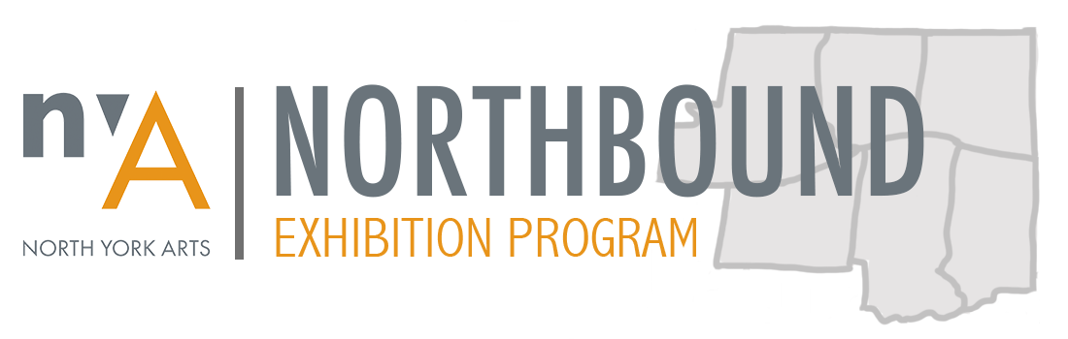

Northbound Exhibition Program 2020 Application

Application Deadline: November 17, 2019 at 11:59 pm

Artist Name*:
*Please note you must designate one person as the primary point of contact.
Group/Collective Name:
Primary Phone: Secondary Phone:
E-mail:
Website:
Instagram: Facebook: Twitter:
Address: Apt #:
City: Postal Code:

How did you hear about the Northbound Exhibition Program?
- Facebook  - Twitter  - Instagram | - NYA e-newsletter  - NYA Staff  - Snapd North York | - Word of Mouth  - Other (Please Specify):  ____________________

ABOUT - INDIVIDUAL ARTISTS ONLY

Do you identify with any of the following? (Check all that apply)
- Emerging Artist  - New-Generation (18-29) | - Newcomer  - North York Resident

Artist Statement (max 200 words)

Artist Biography (max 200 words)

Short summary of artist biography and statement (max 75 words)
(If selected this will be used for marketing purposes)

Please outline your past exhibitions (max 200 words)
(Point form)

ABOUT - GROUPS ONLY

Number of group members:

List the full names of all group members:

Note the number of group members who identify with the following:

Emerging Artist _____ New-Generation (18-29)_____ Newcomer_____
North York Resident_____

Group mandate or purpose (max 200 words)

Group profile - summarize your member biographies (max 200 words)

Short summary of group mandate and profile (max 75 words)
(If selected this will be used for marketing purposes)

Please outline your past exhibitions (max 200 words)
(Point form)

PROPOSED EXHIBITION DETAILS

Please select the months you are NOT available to hold an exhibition in 2020:
- April  - May | - June  - Sept | - Oct  - Nov

Proposed exhibition title

Proposed exhibition concept, themes, and content (max 300 words)

Short exhibition description (max 75 words)
(If selected this will be used for marketing purposes)

Please explain why your exhibition is relevant to residents living in North York; How the concepts and themes of your exhibition would relate to and/or impact the lives of North York community members? (max 150 words)

Technical description of exhibition
The provided exhibition space is comprised of 12 movable walls (48”L x 12”W x 90”H). Only artworks that can be securely fixed to these walls are permitted. Artworks that exceed wall dimensions or cannot be hung (ie. sculptures, large installations, etc) will not be accommodated.

In the chart below, please provide the medium(s) and dimensions of the artworks you intend to display. Note the number of artworks of each medium and size you will include in the proposed exhibition.

Number of Works | Medium | Dimensions (inches)

Work Plan
Northbound Exhibition Program participants are solely responsible for the preparation, transportation, installation, and removal of artworks in the proposed exhibition. This involves undertaking associated costs, securing assistance as needed, and dedicating time to coordinate and execute tasks by given deadlines.

How do you plan to cover the costs associated with the preparation, transportation, installation, and removal of artworks? If you cannot currently cover these costs, what steps will you take to secure financial support? (max 150 words)

What skills, experiences, or resources will you draw upon to ensure the successful and professional execution of your exhibition by given deadlines? (max 150 words)

SUPPORT MATERIALS

In addition to this application form, applicants must submit 10 digital images and an image list for review.

Images
Images should accurately show the artwork that will appear in the proposed exhibition. If unavailable, please submit images of your previous work that reflect the type of pieces you intend to exhibit.

- Image Format: JPEG.
- Maximum Size: 15MB all together
- File Name: Northbound_2020_APPLICANT NAME_IMAGE NUMBER
Please Note: The jury will view images on a computer; therefore, images must be large enough to be viewed clearly with good resolution. Photographs or printed images are not acceptable for our jurying process. No slides please. NYA may use images of accepted work for promotional purposes.

Image List
The image list should indicate the following information for each submitted image: number (same as image file name), title, medium, artwork dimensions in inches, artist name and year of creation. See page 7 for an Image List Template.

- File Format: PDF
- File Name: Northbound_2020_APPLICANT NAME_Image List

SUBMISSION INSTRUCTIONS

Submit all files together via WeTransfer.com to submissions@northyorkarts.org. In the “Message” section write your name or group’s name. Click “Transfer” to submit.

Complete applications must include:
- PDF Application Form: Northbound_2020_APPLICANT NAME_Application
- 10 Digital Images: Northbound_2020_APPLICANT NAME_image number
- Image List: Northbound_2020_APPLICANT NAME_Image List

Complete applications must be submitted via WeTransfer.com no later than 11:59pm on November 17, 2019.

IMAGE LIST TEMPLATE

# | Title | Medium | Dimensions (inches) | Artist | Year
1
2
3
4
5
6
7
8
9
10

DECLARATION AND SIGNATURE

Declaration of Application and Acceptance of the Terms of Entry
I certify that the information in this application is true, that the artworks submitted are mine/my groups, and that I have the authority to make this application on behalf of my arts group. I understand that acceptance of this application to exhibit is the sole discretion of the NYA Northbound Exhibition Program Jury. In addition, I certify that I have read and understand the NYA Northbound Exhibition Program Guidelines and will ensure that all artists participating in this exhibition are provided with a copy of the NYA Northbound Exhibition Program Guidelines and agree to comply with all the stated regulations.

Full Name (print):
Signature: Date:
Please note: The information is used exclusively by NYA staff and volunteers to process applications

THIS SECTION FOR Northbound Exhibition Program Jury and staff use only

Date Application Received:
Date Application Reviewed:
Date Artist Notified:
☐Approved ☐Not Approved ☐More Info Requested ☐ Waitlist

NYA Gallery Chair Signature: Date:

