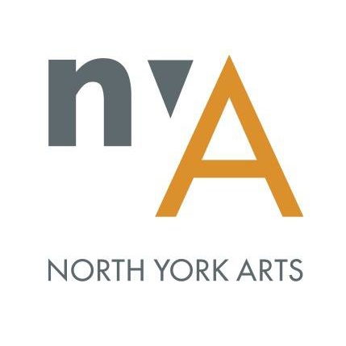

Student Placement/Internship Application Form

Placement Start Date *
Placement End Date *
Please, note If your start and end date are flexible.
Hours to Complete *

Students Information
Name *
Address
Phone Number
Email Address *
Health Concerns/Allergies
School and Program
Institution *
Year of Study *
Program *
Placement Supervisor *
Supervisor Email Address *

Availability
What is your availability for your placement? Hours per week: * (Ex. 15 hours/ week)
Availability (check all that apply) *
- Monday:
- Tuesday:
- Wednesday:
- Thursday:
- Friday:
- Saturday:
- Sunday:
Please specify the hours that you are available for the checked days above
(Ex. Mondays: 3:00pm - 6:00pm, Thursdays: 9:00am - 12:00pm and 4:30pm - 6:00pm, Fridays: all day)
* Internships are usually available during NYA office hours Monday through Friday from 9am to 5pm. However, events, programs and meetings can take place in the evenings and/or on weekends.

Experience and Interests
Please list any specific skills and previous experience you think you could bring to this placement. *
Do you speak a second language? *
- YES
- NO
If yes, which one(s):
How did you hear about North York Arts? *
Why do you want to intern at North York Arts? *
What do you hope to achieve and learn through this placement? Include a brief description of at least 3 of your learning objectives and/or area of interest to apply your skills.*

