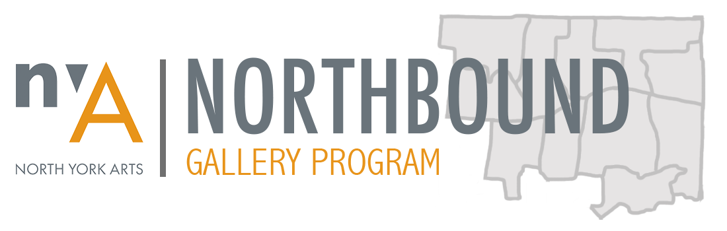

Northbound Gallery Program Application 2019

Artist/s Name*:
*Please note you must designate one person as the primary point of contact.
Group/Collective Name:
Primary Phone: Secondary Phone:
E-mail:
Website:
Address: Apt #:
City: Postal Code:
- Are you currently living in North York?:
  - If you are a group or collective, how many of your members live in North York?:

- Are you currently part of the NYA Network?:
  - If you answered no to the previous question, would you like to become part of the NYA Network? (by saying yes to this question you are agreeing to opt-in to the NYA e-newsletter) :

3. How did you hear about the Northbound Gallery Program?
Facebook ___ Twitter ___ Instagram ___ NYA e-newsletter ___Direct email ___
Snapd North York ___ Word of Mouth ___ Other (please specify):

4. Have you exhibited with North York Arts before? If so, when was your last exhibit?

Requested dates for Exhibition
All decisions regarding the approval of Northbound applications and the scheduling of exhibitions are made by the NYA Northbound Gallery Program Jury. Exhibitions will be between 1-3 weeks in duration. In order to assist the jury with this process, please provide the following information:
5. Please list, in order, your top 3 preferred months to hold an exhibition in 2019:

6. Please select the months you are NOT available to hold an exhibition in 2019:
Jan __ Feb __ Mar __ Apr __ May __ Jun __ Jul/Aug __ Sept __ Oct __ Nov __ Dec __
ABOUT ARTIST/ ARTS GROUP
7. Artist Biography (for individual artists only) (200 words max):

8. Artist Statement (for individual artists only) (200 words max):

9. Group/collective mandate or vision (for group/collective only) (200 words max):

10. Brief description of Group/collective members (for group/collective only) (200 words max):

11. Please provide us with a brief overview of you or your group’s work (150 words max):

12. If applicable, please list or describe past participation in group and individual shows (200 words max):

PROPOSED EXHIBITON DETAILS

13. Proposed title of exhibition:

14. Proposed exhibition summary outlining theme, concept and/or content (300 words max):

15. Technical description of exhibition:
Please describe below the type of art/ mediums in your exhibition including estimated number of small works (all outside dimensions smaller than 24", estimated number of large works (one or both dimensions larger than 24"), estimated number of 3D works for display cases, and/or other technical requirements.

16. How will your show engage/ be relevant to the North York community? (150 words max):

17. Have you received a grant or funds for this exhibition? If so please describe what funds you have secured and if any funds will go towards paying artists (100 words max):

Installation and Strike
The installation and strike of work in the exhibition space will be the responsibility of the applicant. You are responsible for providing the necessary help for delivering, installing, taking down and removing your artwork.

18. What is your ability to undertake this project? Are you/your group able to take on the responsibilities associated with this project and execute them in a professional manner? (150 words max):

IMAGES AND IMAGE LIST

19. Images:
Please include 10 electronic images of the work you intend to show or, if unavailable, images of your previous work that reflect the type of pieces that you intend to show.

PLEASE NOTE: The jury will view images using a computer; therefore, images must be large enough to be viewed clearly with good resolution. Photographs or printed images are not acceptable for our jurying process. No slides please. NYA may use images of accepted work/s for promotional purposes of the exhibition.

- Image Format: JPEG.
- Maximum Size: each image should be 72 dpi and no larger than 1024 x 1024 pixels. All together, images should not exceed 15MB.
- Minimum size: no less than 500 x 500 pixels (height & width) and 72 dpi
- File Names: images should be named as follows: Northbound_2019_NAME_IMAGE NUMBER
20. Image List:
In Addition to the images, please Include an image list indicating number, artist name, title, medium dimensions in inches, and year for each image. All images must be numbered and referred on the images list.

- File Format: PDF
- File Name: Northbound_2019_NAME_ImageList

21. How to submit Application, Images and Image List:
Application, images and image list must be submitted ALL TOGETHER through WeTransfer: https://wetransfer.com/ using the email submissions@northyorkarts.org (see below for full submission instructions)

STEPS to submit application/ images/ image list:
- Download and fill out application
- Once completed, save file as a PDF with the file name: Northbound_2019_NAME_Application
- Go to WeTransfer.com
- Upload ALL necessary files i.e. completed application, 10 images, image list
  - Specifications for image and image list submission are outlined above
- Email to: submissions@northyorkarts.org
- In the “message” section please write your name and your group’s name (if applicable).
- Click “Transfer” to submit

DECLARATION AND SIGNATURE

Declaration of Application and Acceptance of Terms of Entry
I certify that the information in this application is true, that the artwork submitted is mine/my groups, and that I have the authority to make this application on behalf of my arts group. I understand that acceptance of this application to exhibit is the sole discretion of the NYA Northbound Gallery Program Jury. In addition, I certify that I have read and understand the NYA Northbound Gallery Program guidelines and will ensure that all artists participating in this exhibition are provided with a copy of the NYA Northbound Gallery Program guidelines and agree to comply with all the stated regulations.

Name (print): Date:
Signature

Please note: The information is used exclusively by NYA staff and volunteers to process gallery applications

THIS SECTION FOR Northbound Gallery Program Jury and staff USE ONLY
Application received on:
Application reviewed by Gallery Jury on:
Application approved ☐ Not approved ☐ More info requested ☐ Waitlist ☐
NYA Gallery Chair Signature: |  | Date:  Artist notified on:

